Assignment 4

**Question 1:** How are inline and block elements different from each other?

**Ans :** An inline element does not start on a new line and only takes up as much width as required.

**Eg.:** span, br, img, button etc.

While block element always starts on a new line and takes full width available.

**Eg.:** div, form, hr, nav, li.

**Question 2:** Explain the difference between visibility:hidden and display:none

**Ans: display:none** means that the tag in question will not appear on the page at all but we can still interact with it through the DOM. There will be no space allocated for it between the other tags.

**Eg.** Some text ABCDEFGHIJKLMNOPQRST some text.

Some text <span style=”display:none”>ABCDEFGHIJKLMNOPQRST</span> some tesxt.

**Output :** some text some text.

**Visibility:hidden** means that tag element will not be displayed but the space is allocated for it on the page. The tag is rendered,but is not seen on the page.

**Eg.** Some text ABCDEFGHIJKLMNOPQRST some text.

Some text <span style=”visibilty:hidden”>ABCDEFGHIJKLMNOPQRST</span> some tesxt.

**Output :** some text some text.

**Question 3:**Explain the clear and float properties.

**Ans :**  **Clear** property specifies what element can float beside the cleared elemet and on which side.

The *clear*  property can have following values :

* Left: no floating allowed on the lift side.
* Right: no floating allowed on the right side.
* Both: no floating element allowed.
* Inherit: element inherit clear value of its parent
* None: this is default, allows floating element on both sides.

**Eg.** div {  
 clear: left;  
 }

**Float:** It is used to positioning and formatting content eg. Let an image float left to the text in a container.

The *float* property can have any one of the following values:

* Left: the element float to the left of its container.
* Right: The elemet float to the right of its container.
* None: this is default. The element will not float.
* Inherit: Inherit float values off its parent.

**Eg.** img {  
 float: right;  
 }

**Question 4:** explain difference between absolute, relative,fixed and static.

**Ans : Absolute :** Absolute positioning an HTML element positions the element to its nearest positioned parent. Thus it refers to the nearest parent’s position.

**eg.** Position : absolute;

**Relative:** Making an HTML element relative, gives you the privilege to move the element from its current position. It does not refer to a different element’s position.

**Eg.** Position:relative;

**Fixed:** In this div is fixed where you code and is relative to viewport not to any other element.

**Static:** It is default value. Element render in order as they appear in the document flow.

**Question 5:** Write the HTML code to create a table in which there are 4 columns( ID , Employee Name, Designation, Department) and at least 6 rows. Also do some styling to it.

**Ans :** A HTML file is attached with this assignment.

**Question 6:** Why do we use meta tags?

**Ans :** <meta> tags are used to provide metadata about HTML document. Metadata will not be rendered on the screen, but M/C can parse it.

It always put inside <head> element.

**Use of Meta Tags:**

* SEO(Search Enginer Optimization)
* Keywords
* Page description
* Author of documents
* Last modified
* To set the viewport
* Refresh document on specified time
  + <meta http-equiv=”refresh” content=”20”>

**Question 7 :** Explain box model.

**Ans :**

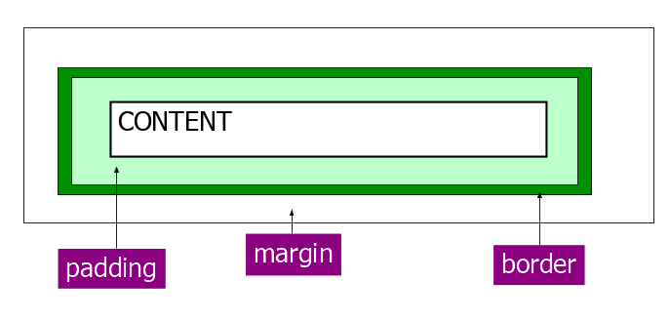

All HTML element can be considered as boxes. In CSS the term ‘box model’ is used when talking about design and layout.

**Content:** The content of the box, where text and images appear.

**Padding:** Clear an area around the content. The padding is transparent.

**Border:** A border that goes around the padding and content.

**Margin:** Clears an area outside the border. The margin is transparent.

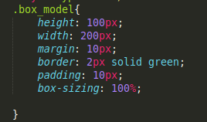

**Question 8:** What are the different types of CSS Selectors?

**Ans:**  In CSS, Selectors are the patterns used to select the elements to style.

**Syntax:** selector {

Property:value;

}

Some examples:

1. **Class :**  it is used to make group of similar class of elements.



1. **ID :** Provide unique id to each element.

Uses # sign in CSS styling.

1. **TAG name :** we can also define CSS using tags name.

P{ color:red; }

1. Selector > element : selects all element where selector is parent.

**Question 9 :** Define Doctype.

**Ans :** The <!DOCTYPE> declaration is not an HTML tag; it is an instruction to the web browser about what version of HTML the page is written in.

The <!DOCTYPE> declaration must be the very first thing in your HTML document, before the <html> tag.

**Syntax :** <!DOCTYPE html>

**Question 5:** Explain 5 HTML5 sematic tags.

**Ans:** Semantic tags clearly defines its content.

1. **<form>** content is input fields to take input from user.
2. **<table>** content is a table of row and column.
3. **<header>** defines the header of page.
4. **<footer>** defines footer of the page.
5. **<nav>** defines the navigation bar of the webpage.

**Question 11:** Create HTML for web-page.jpg (check resources, highest weightage for answers).

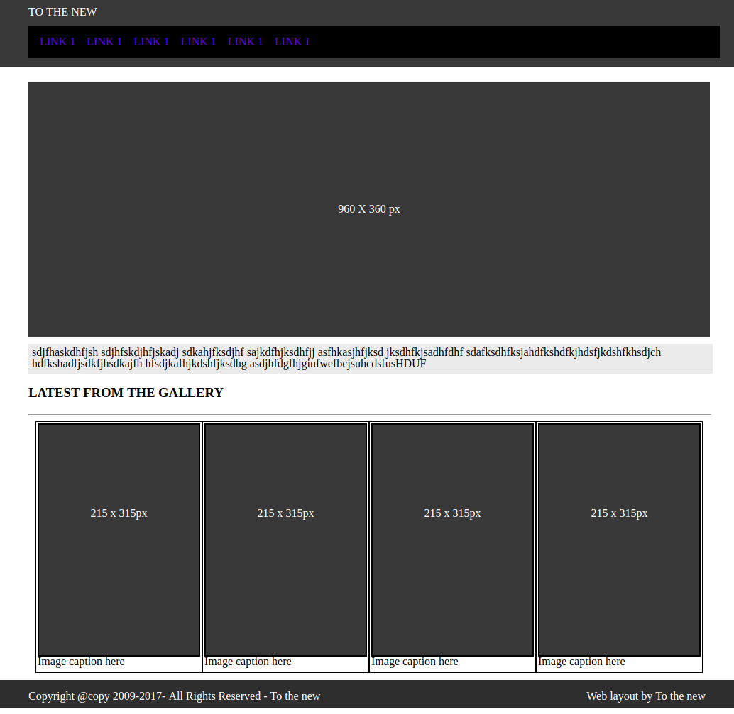

**Ans :** A HTML file is attached.

[CLICK HERE FOR HMTL CODE](https://github.com/Abhivirusonline/Introduction_to_databases/blob/master/11.html)

[CLICK HERE FOR CSS CODE](https://github.com/Abhivirusonline/Introduction_to_databases/blob/master/style.css)

**Question 12 :** 12. Create HTML for form.png (check resources, highest weightage for answers)

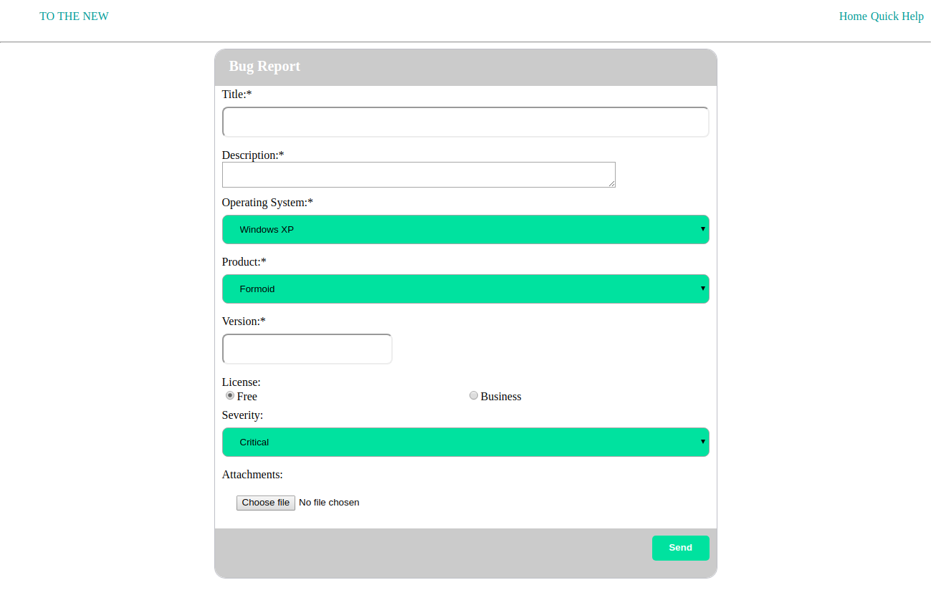

**Ans :** A HTML file is attached.

[FOR HTML CODE](https://github.com/Abhivirusonline/Introduction_to_databases/blob/master/12.html)

[FOR CSS CODE](https://github.com/Abhivirusonline/Introduction_to_databases/blob/master/bug.css)